**Capstone Project – Weather Analysis**

**Objective:**

The objective outlines the purpose of the analysis, defining the specific questions or problems that need to be addressed. It serves as the foundation for the entire project, guiding the direction of the analysis and ensuring that all efforts are aligned with the intended outcomes.

**Analysis Scope:**  
The analysis covers six key aspects: humidity, pressure, temperature, wind direction, wind speed, and weather descriptions. Each factor will be examined to identify trends and anomalies.

**Goal:**The overarching goal is to derive actionable insights from the historical weather data set. These insights will empower stakeholders in sectors like agriculture, energy management, urban planning, and transportation.

**Insights and Recommendations:**  
The project will generate key insights and actionable recommendations based on the analyzed data. This information will be essential for adapting strategies to cope with changing weather patterns and enhancing decision-making.

**Reports and Presentations:**  
Findings will be compiled into a comprehensive report, supplemented by data visualizations to illustrate key trends. Presentations will be designed to make the insights accessible and understandable to a wide audience.

***Interactive dashboards will be employed to visualize complex weather data relationships. This tool will help users grasp insights more effectively, facilitating better planning and decision-making.***

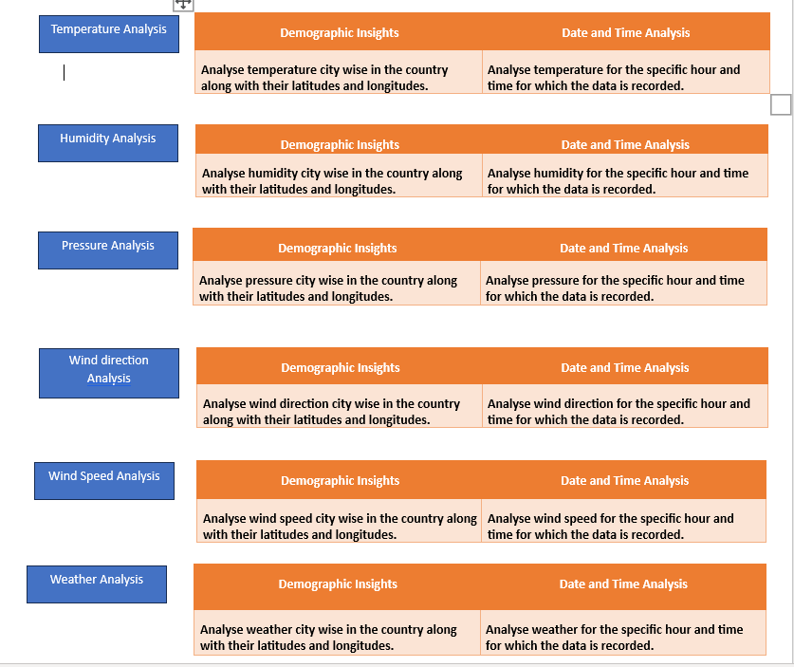

**Valuable Insights:**

The project provides critical insights into various weather patterns, which are essential for informed decision-making across multiple sectors. By analyzing factors such as temperature, humidity, and atmospheric pressure, stakeholders can enhance resource management, optimize operational strategies, and improve risk mitigation efforts.

**Improvement Focus:**

A continuous improvement focus is essential for adapting strategies based on evolving weather data and insights. By regularly reassessing methods and practices, organizations can enhance their resilience and effectiveness in responding to weather-related challenges.

**Evaluation of Effectiveness:**

Evaluating the effectiveness of strategies involves systematically analyzing outcomes against predetermined benchmarks and objectives. This rigorous assessment process not only identifies successes and failures but also provides insights for continuous improvement and adaptation in response to changing conditions.

**Trend Identification:**

Identifying trends in weather data is essential for proactive decision-making, allowing organizations to anticipate changes and adjust their strategies accordingly. This involves analyzing historical data to recognize patterns and anomalies that can inform future actions in sectors like agriculture, urban planning, and disaster management.

**Comprehensive Understanding:**

A comprehensive understanding of weather data involves integrating various meteorological factors, historical patterns, and real-time information to inform holistic decision-making. This multifaceted approach allows organizations to develop effective strategies that address the complexities of weather variability and its impacts on different sectors.

**ER Diagram:**

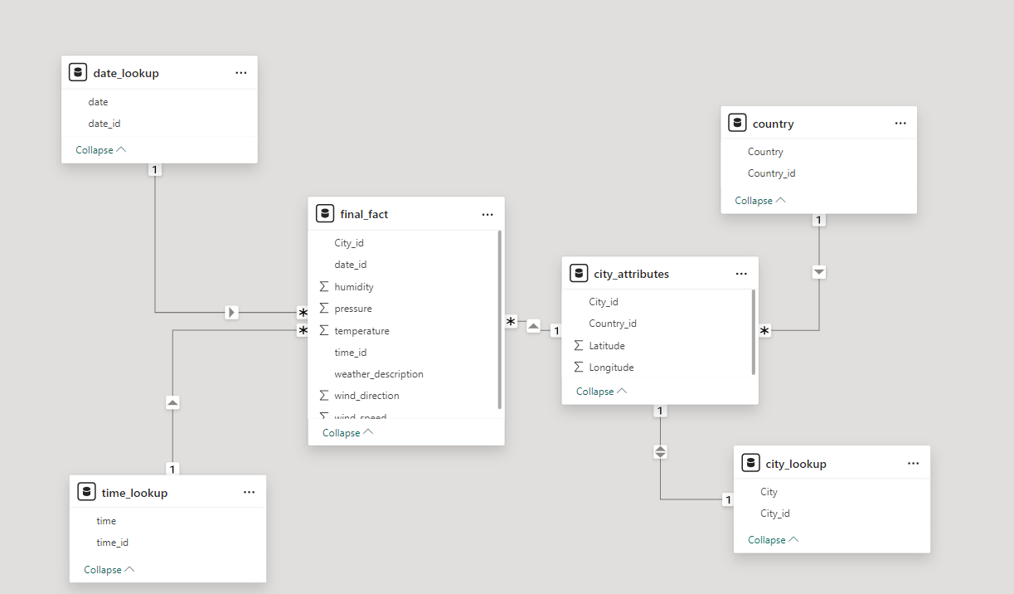

**Power BI Problem Statements:**

1. **Can you create a geographical map in Power BI showing the distribution of cities in the dataset based on their latitude and longitude?**

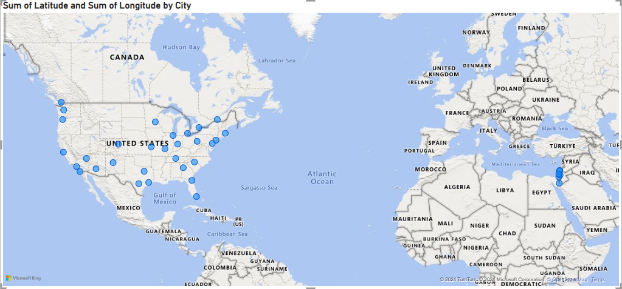

1. **In Power BI, can you create a bar chart representing the top 10 countries with the highest number of cities in the dataset?**

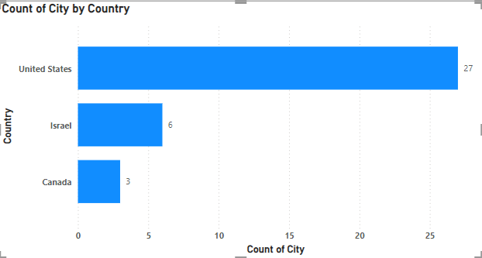

1. **How does the distribution of cities in terms of latitude vary across different continents? Create a scatter plot in Power BI to illustrate this.**

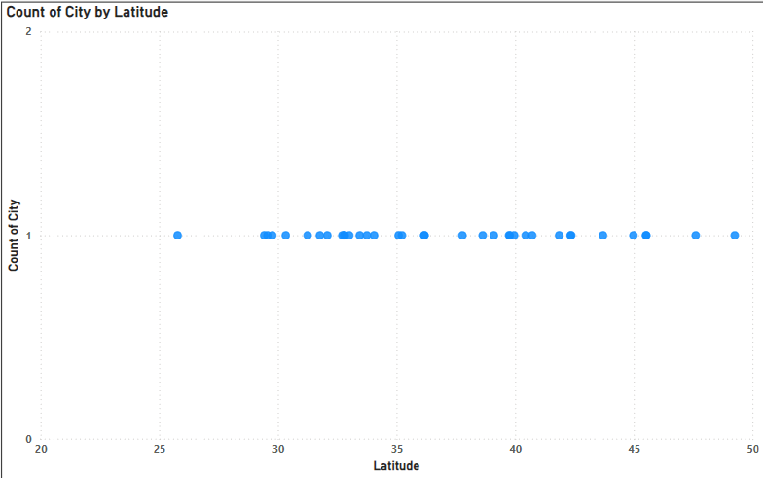

1. **Create a line chart in Power BI to display the temperature trends over time for a selected city. Highlight extreme temperature events.**

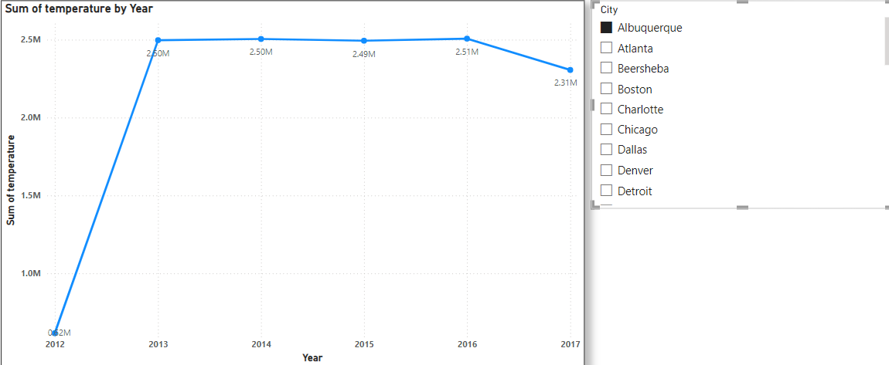

1. **How does humidity vary across different cities? Generate a heatmap in Power BI to visualize this variation.**

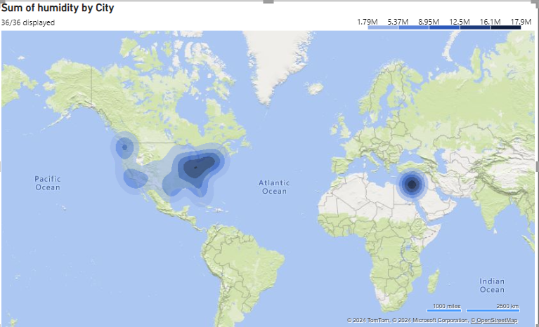

1. **Can you create a time-series chart in Power BI showing the relationship between wind speed and air pressure for a specific city?**

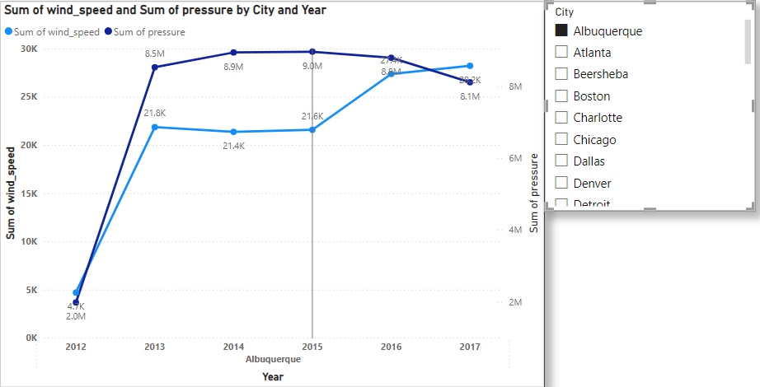

1. **Create a time-series line chart in Power BI to show the overall temperature trends over the entire dataset.**

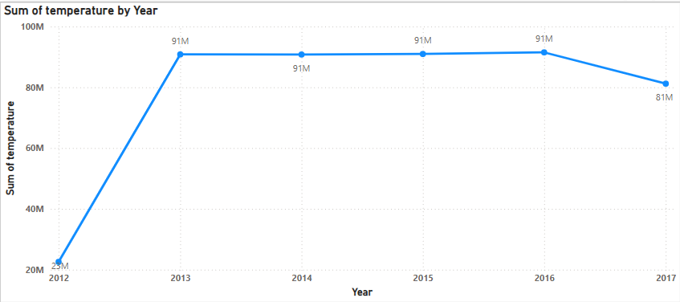

1. **Can you create a heatmap in Power BI to visualize the busiest hours for specific weather conditions (e.g., "clear sky," "rainy")?**

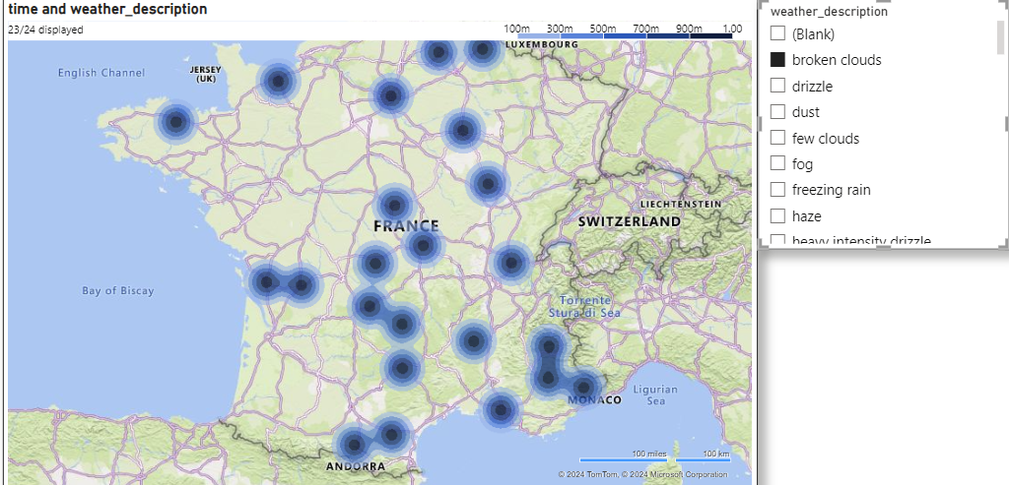

1. **How does the wind speed change over the course of a day? Create a radial chart in Power BI to represent this.**

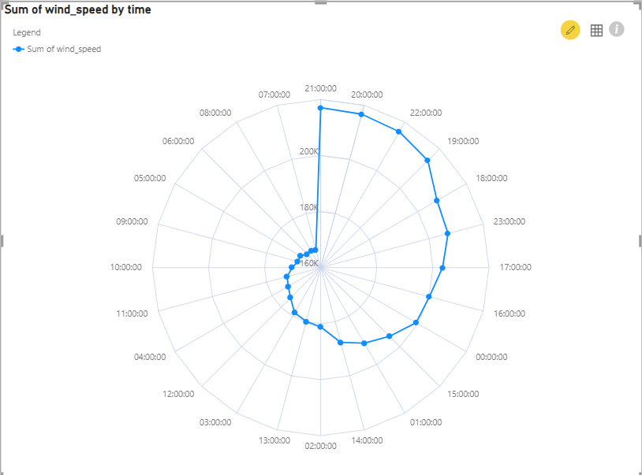

1. **Create a Power BI chart comparing the temperature variations between two selected cities over a specific timeframe.**

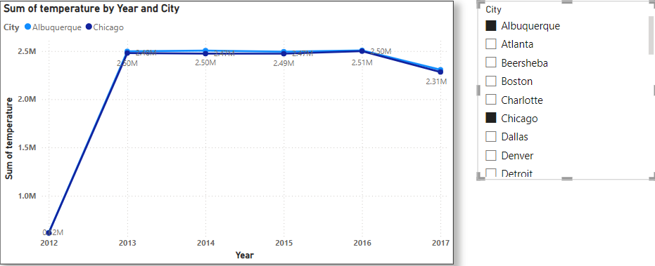

1. **Can you build a heatmap in Power BI to show the temperature ranges for cities across different countries?**

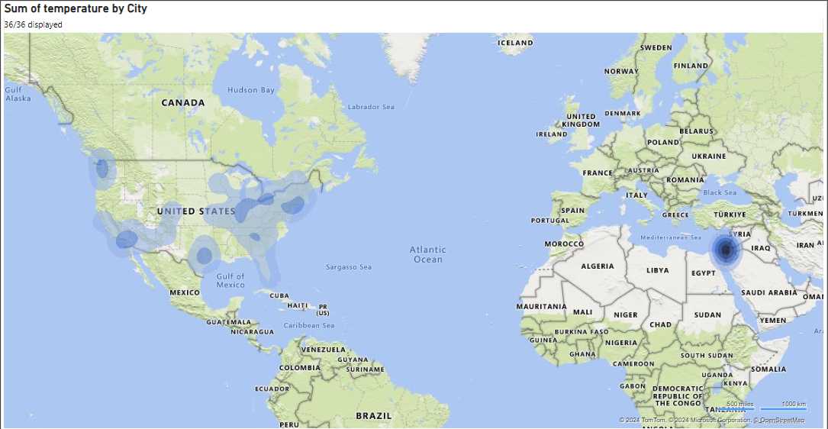

1. **Create a bar chart in Power BI to highlight cities with the highest and lowest average temperatures in the dataset.**

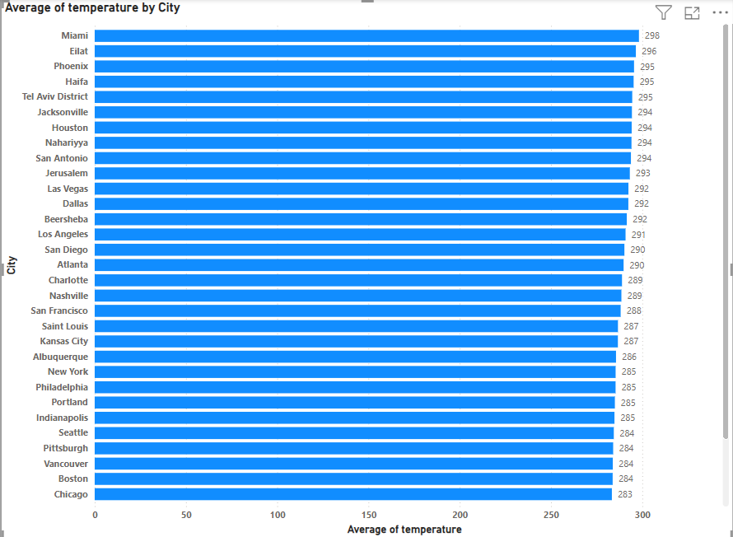

1. **Create a wind rose chart in Power BI to visualize the prevailing wind directions for a selected city.**

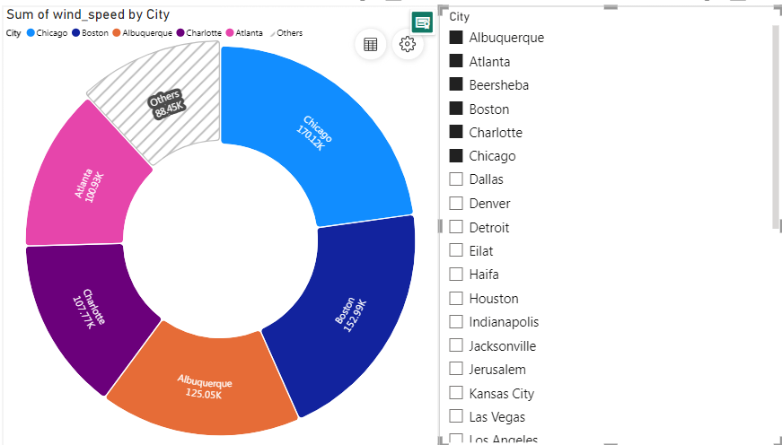

1. **Can you generate a Power BI heatmap illustrating the average wind speeds across cities for different months of the year?**

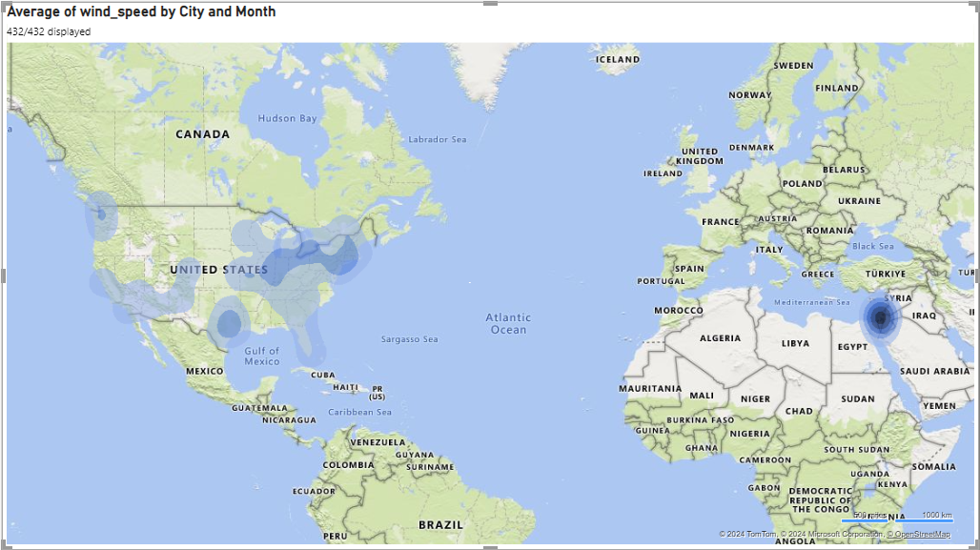

1. **Create a Power BI scatter plot to show the relationship between wind speed and air pressure for a specific city.**

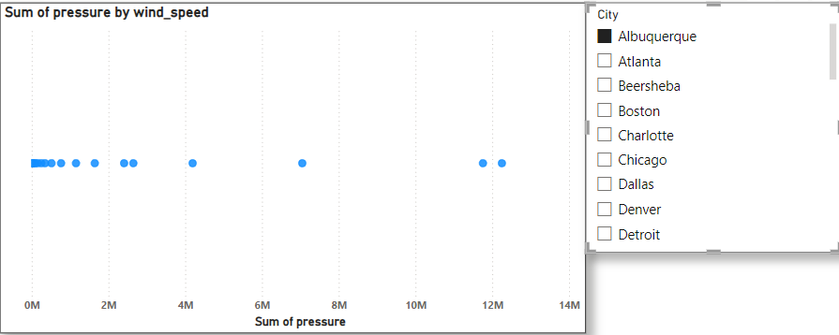

**Dashboard:**

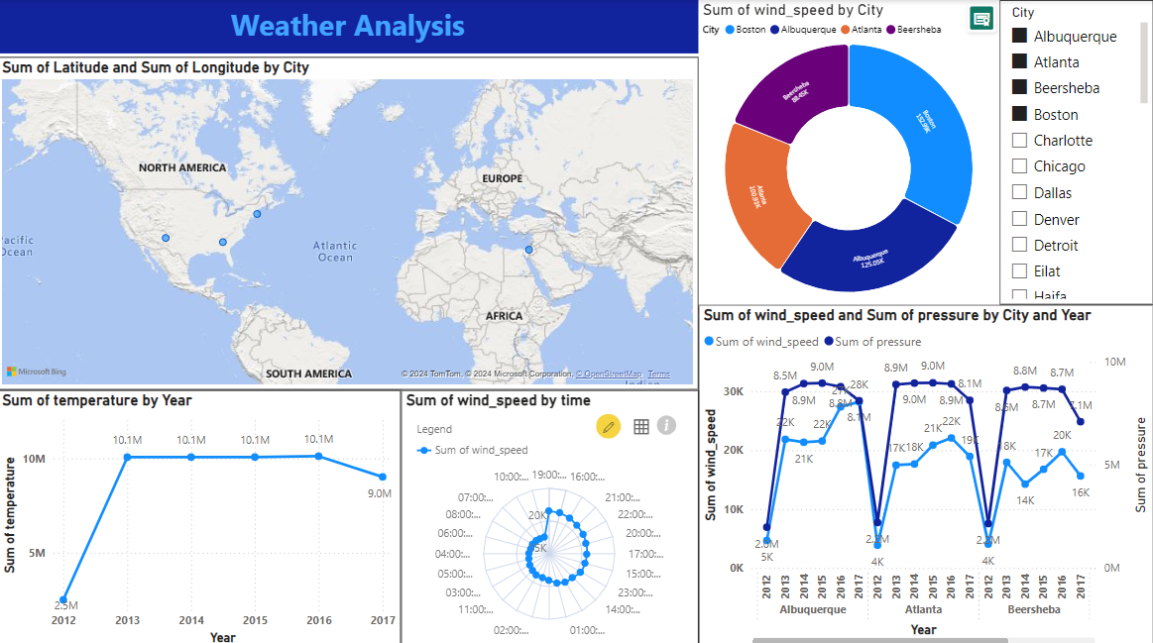

**Excel Problem Statements:**

1. **Are there any countries with cities located at extreme latitudes, and how might this impact their climate?**

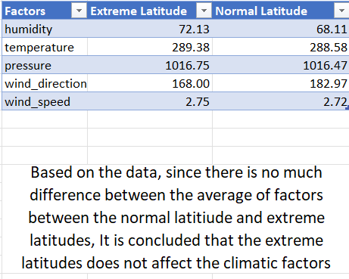

1. **Can you identify any clusters of cities with similar latitude and longitude values? What factors might explain these clusters?**

From the Retrieved data of cluster of cities with similar latitude and longitude, it is found that no factors expain these clusters

1. **Are there any correlations between a city's geographical location (latitude and longitude) and its weather attributes, such as temperature or humidity?**

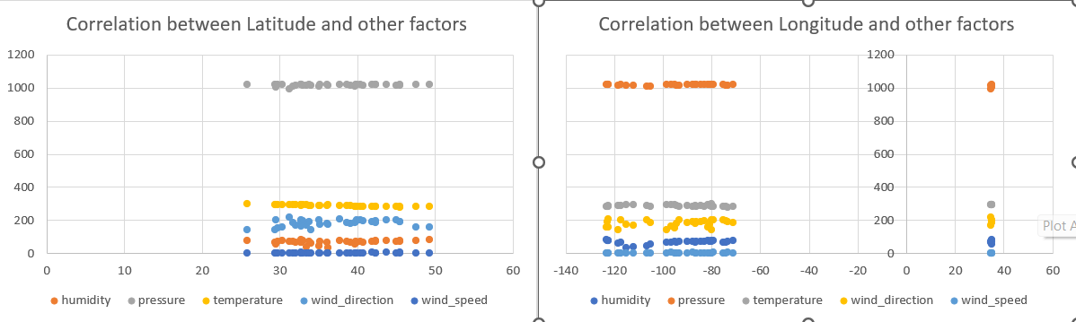

Yes there is a positive correlation between geographical location and it’s weather attributes.

1. **Identify the top three cities with the most frequent occurrence of rainy weather based on weather descriptions. What are the seasonal patterns?**



1. **Is there a correlation between humidity levels and air pressure? How might this relationship affect weather conditions?**

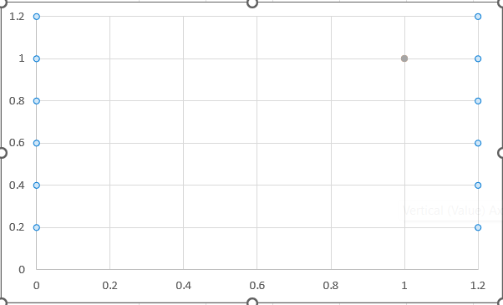

The correlation between humidity levels and air pressure affect the weather condition significantly

1. **Are there specific months when cities experience significant temperature fluctuations? What might explain these variations?**

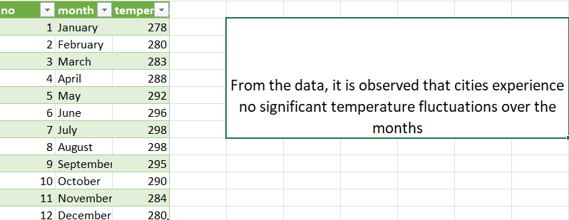

1. **Identify periods of extreme weather events, such as storms or heatwaves, by analyzing the time-based data. What patterns emerge?**

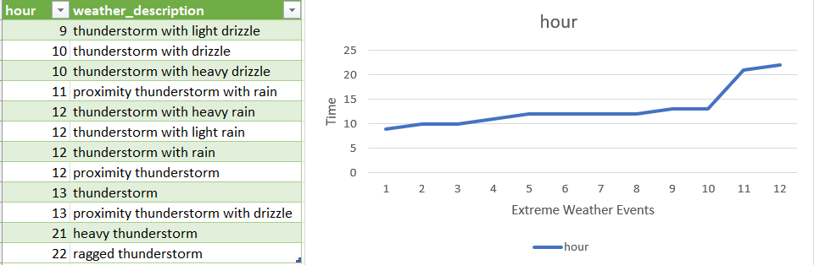

1. **What are the consequences of prolonged periods of extreme cold or heat in specific cities? How do residents adapt to such conditions?**

Extreme cold causes health risks, frozen pipes, and higher heating costs, while extreme heat leads to heatstroke, power outages, and water shortages. Residents adapt with heating systems or air conditioning, insulated homes, and hydration strategies. Cities use snow removal or shade trees and reflective materials to manage conditions.

1. **Investigate whether temperature anomalies (unusual deviations from the norm) coincide with certain events or environmental factors in specific cities.**

From the data, it is observed that there is no unusual deviations from the normal temperature to coincide with certain events or environmental factors in specific cities

1. **Identify cities prone to strong winds and the potential consequences, such as increased risk of natural disasters or challenges for transportation.**

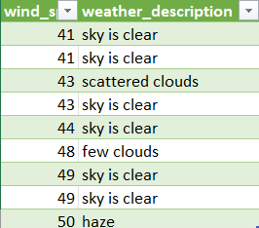

For the high values of wind speed which are stron winds, there is no extreme weather condition from the given data. However generally Strong winds, especially during cyclones or typhoons, significantly increase the risk of natural disasters, causing widespread flooding, landslides, and structural damage. trong winds disrupt transportation by causing flight cancellations, road blockages from fallen trees, and train service delays due to obstructions.

1. **Explore whether wind speed and direction influence the frequency and severity of weather-related events (e.g., hurricanes, storms) in coastal cities.**

|  |  |  |
| --- | --- | --- |
| **wind_speed** | **wind_direction** | **weather_description** |
| 2 | 160 | fog |
| 2 | 180 | heavy thunderstorm |
| 2 | 188 | sky is clear |
| 3 | 78 | proximity thunderstorm with drizzle |
| 3 | 95 | tornado |
| 3 | 96 | shower drizzle |
| 3 | 139 | volcanic ash |
| 3 | 146 | light intensity drizzle rain |
| 3 | 155 | proximity sand/dust whirls |
| 3 | 158 | drizzle |
| 3 | 158 | heavy intensity drizzle |
| 3 | 161 | light intensity drizzle |
| 3 | 169 | mist |
| 3 | 171 | proximity thunderstorm |
| 3 | 173 | very heavy rain |
| 3 | 177 | overcast clouds |
| 3 | 177 | heavy intensity rain |
| 3 | 178 | haze |
| 3 | 180 | broken clouds |
| 3 | 180 | light rain |
| 3 | 180 | moderate rain |
| 3 | 182 | scattered clouds |
| 3 | 188 | few clouds |
| 3 | 194 | smoke |
| 4 | 121 | thunderstorm with drizzle |
| 4 | 162 | proximity thunderstorm with rain |
| 4 | 169 | thunderstorm with light drizzle |
| 4 | 172 | thunderstorm |
| 4 | 178 | light intensity shower rain |
| 4 | 180 | thunderstorm with rain |
| 4 | 181 | snow |
| 4 | 182 | thunderstorm with heavy rain |
| 4 | 183 | thunderstorm with light rain |
| 4 | 193 | proximity moderate rain |
| 4 | 194 | proximity shower rain |
| 4 | 214 | light snow |
| 4 | 252 | sleet |
| 4 | 340 | thunderstorm with heavy drizzle |
| 5 | 108 | freezing rain |
| 5 | 150 | sand/dust whirls |
| 5 | 150 | rain and snow |
| 5 | 189 | dust |
| 5 | 196 | heavy intensity shower rain |
| 5 | 198 | light rain and snow |
| 5 | 198 | shower rain |
| 5 | 211 | heavy snow |
| 5 | 215 | shower snow |
| 6 | 233 | heavy shower snow |
| 6 | 234 | light shower sleet |
| 6 | 245 | light shower snow |
| 7 | 212 | sand |
| 7 | 252 | squalls |
| 8 | 295 | ragged thunderstorm |
| 9 | 254 | ragged shower rain |

As the value of wind_speed and wind_direction increases, extreme weather condition is observed from the data. So it is concluded that wind speed and direction influences the severity of weather related events.

**Conclusion:**

Based on the analysis, the climatic factors remain largely unaffected by latitude variations, and no significant correlations explain the clustering of cities with similar geographic coordinates. Cities exhibit stable temperatures over time without unusual deviations linked to specific events. However, wind speed and direction are identified as key influencers of severe weather conditions, although no extreme weather events were observed in the provided data. In conclusion, the data suggests overall climatic stability with wind dynamics being a crucial factor in weather severity.